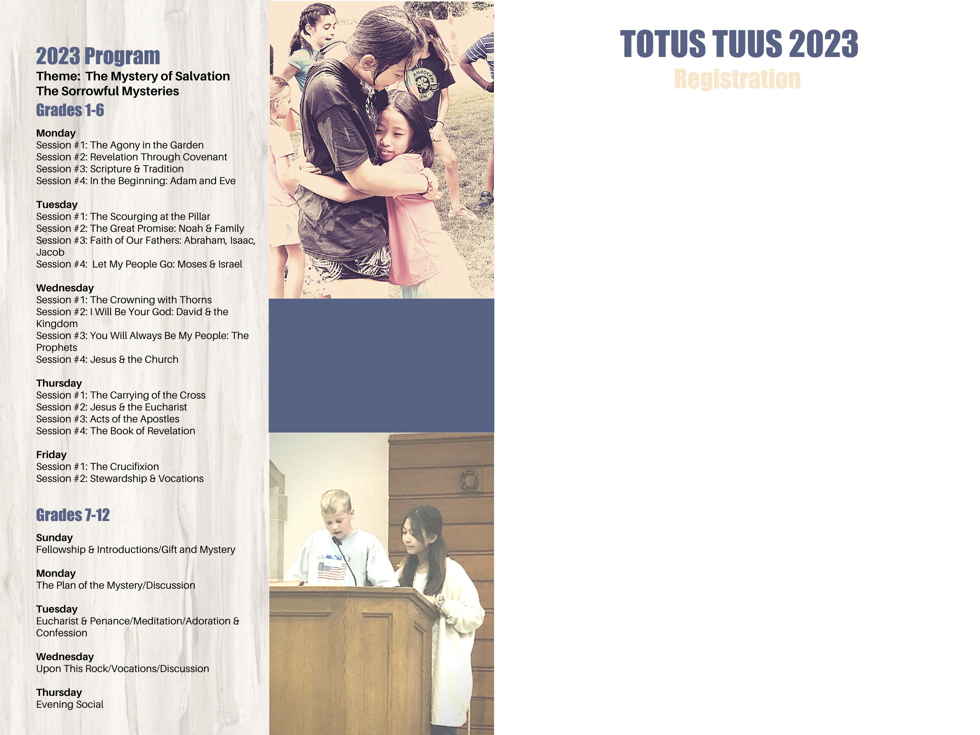:

Parent’s/Guardian’s Name: _____________________________________________

Mailing Address: ______________________________________________________

City: ____________________________ State: ________ Zip Code: _____________

Home Phone: ____________________ Cell Phone: __________________________

Email: ____________________________ Parish: ___________________________

I approve Totus Tuus, the parish, and the Diocese of Winona-Rochester to use my child’s photo on the website or bulletin ____ Yes _____ No

**Emergency Contact:**

______________________ _________________ _________________________

(Name) (Phone) (Relationship to child)

______________________ _________________ _________________________

(Name) (Phone) (Relationship to child)

Child’s Name: _______________________ Date of birth: _________ Grade: ______

(going into)

Allergies and/or other medical condition(s): ________________________________

____________________________________________________________________

Child’s Name: _______________________ Date of birth: _________ Grade: ______

(going into)

Allergies and/or other medical condition(s): ________________________________

____________________________________________________________________

Child’s Name: _______________________ Date of birth: _________ Grade: ______

(going into)

Allergies and/or other medical condition(s): ________________________________

____________________________________________________________________

Recommended Cost per child: (Scholarships available upon request)

We need families to host the team throughout the week by providing meals and/or lodging:

Yes, I am willing to provide ______ a meal ______ lodging

We need parent volunteers available to help serve beverages during breaks:

Yes, I am able to help with ___ snack break (9:45am) ___ lunch (noon) ___ snack break (8pm)

Adult Classroom Helper: Please check one (must be high school or older)

_____7 – 9am ____ 9am-2:30pm _____2:30pm-5:30pm **Weekday available:** _________

Assist with potluck supper on Wed. evening: ____ Set up ____ Clean up

Donate morning snacks and drinks (circle one or list below) Fruits/Vegetables/Cheese/Crackers/

Cookies/Bars List other:______________________________________________________

